IEEE Inertial Sensors 2026 SAMPLE ABSTRACT
AND INSTRUCTIONS FOR ABSTRACT PREPARATION

Doruk Senkal¹, Mohammed J. Ahamed¹, Alexander A. Trusov^{1,2}, and Andrei M. Shkel¹
¹University of California, Irvine, CA, USA and ²Northrop Grumman Corporation, USA

The purpose of your submission is to tell the Program Committee what new results you propose to present. Stater your primary result within the first few sentences. For example: “This paper reports an improved method for reducing cross-sensitivity in micromachined gyroscopes.”

Make sure to identify how the new work differs from previous work of your own group and of other groups, especially work presented at recent and upcoming international meetings. For example: “The fabrication process for the gyroscope was reported at JMEMS 2007 [1], and an analysis of the new electrode pattern which accomplishes the reduction in cross-axis sensitivity will be reported at INERTIAL 2025 [2]. This paper will show a complete set of experimental results on five device geometries and will also report on simulations which provide design guidelines for adapting this method to other types of gyroscopes. The method reported here differs from previous work [3,4] in the specific method of temperature compensation and in the geometry of the electrodes and their placement within the structure.”

After an introduction of the basic ideas and how the work relates to other work, present detailed descriptions of methods, device structures, and examples of specific results, whether experimental or theoretical. These results can be supported by figures and/or tables. For example: “A schematic view of the gyroscope is shown in Figure 1, with a close-up detail of the electrode geometry and placement in Figure 2. The fabrication process is schematically shown in Figures 3. Table 1 shows the ratio of cross-sensitivities to in-plane yaw for a set of five devices fabricated with different overall geometries and sensitivities. Also shown in Table 1 are the simulation results for these specific device geometries using the analysis procedure in [2]”. After presentation of results, it is useful to compare specific results with related work, to discuss possible discrepancies or agreement, and to comment on the broader impact of the results.

The abstract is limited to two pages (either US Letter or A4). The text is limited to no more than one page. Figures and Tables should be collected on page 2. Please make sure that all figures and photographs are clearly visible and that fonts are large enough for easy readability. If the program committee cannot clearly see and understand the role of the visual material included in the abstract, the material and consequently the abstract likely will be viewed negatively. The title, authors (presenting author underlined), short affiliations, and all the text must fit on the first page, as outlined in this sample abstract. References (in short format) can go on either page. All abstracts submitted on time will be considered for both Oral and Poster Sessions unless the submitting author specifically requests a Poster during the on-line submission process (on the submission form).

References
[1] E. J. Eklund and A. M. Shkel, J. Microelectromech. Syst., 16 (2007), pp. 232-239.
[2] D. Senkal, M.J. Ahamed and A. M. Shkel, Proc. Hilton Head 2012, pp. 267-270.
[3] L. D. Sorenson, X. Gao, and F. Ayazi, Proc. MEMS 2012, pp. 168-171.
[4] B. Etter and A. P. Proach, The Gyro Handbook, 2nd ed. (Singer, 2001), pp. 400-401.

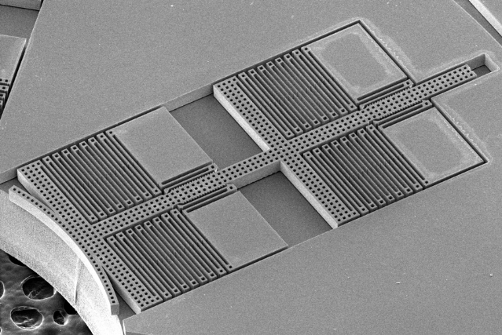
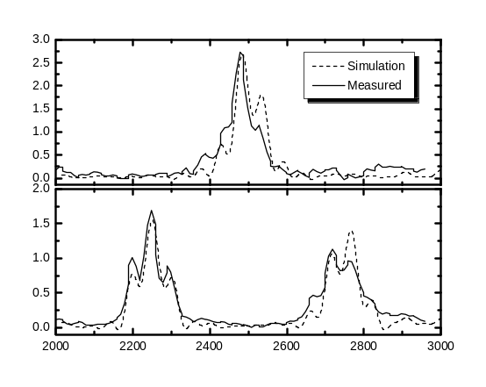
Figure 3. Spectral content of diffracted light from a programmed grating for single (upper) and double (lower) band pass filters. The dashed lines are the simulated spectra while the solid lines are the measured spectra.
Figure 1: 800 μm max displacement along the diameter
allows different sized wineglass resonators to be tested.

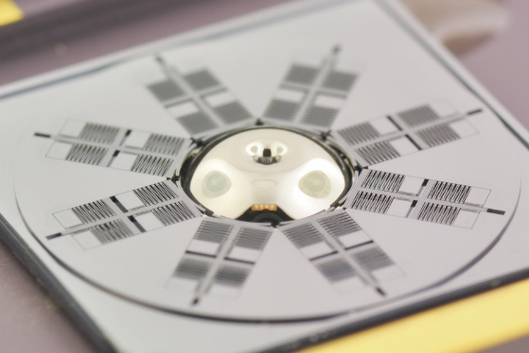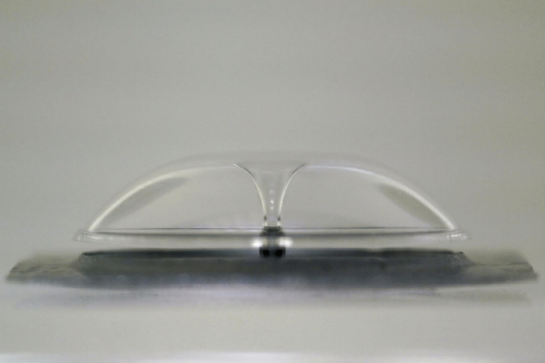
Figure 4. Micro-glassblown wineglass structure with 4.2 mm diameter, 50 μm thickness and 300 μm central stem.
Fig. 2: Electrode structures assembled onto a
micro-glassblown wineglass resonator with <20 μm gaps.

Table 1. Sample of a Table Format
Table Head | Table Column Head
Table Head | Table Column Subhead | Subhead | Subhead
Copy | More table copy

