TOPIC N° X – YYY

TITLE (ARIAL 10, BOLD)

Main Author (Arial 10 underlined)¹, Co-author (Arial 10)²

¹ Company or Institute of affiliation Name + complete address
² Company or Institute of affiliation Name + complete address

Abstract 3000 characters (Arial 10) without picture or 2000 characters (Arial 10) with picture

One page A4 maximum

See the example here after

TOPIC N° 1 – Methods, tools and technologies for SSbD purposes

The History of the Roman Constitution

Jacques Dupond¹, Bertrand Durand²

¹ Univ. Grenoble Alpes, CEA, Liten, DTNM, 38000 Grenoble, France
² CEA Saclay – Lab X, F91191 Gif-sur Yvette, France

The History of the Roman Constitution is a study of Ancient Rome that traces the progression of Roman political development from the founding of the city of Rome in 753 BC to the collapse of the (Western) Roman Empire in 476 AD. The constitution of the Roman Kingdom vested the sovereign power in the King of Rome. The king did have two rudimentary checks on his authority, which took the form of a board of elders (the Roman Senate) and a popular assembly (the Curiate Assembly). The arrangement was similar to the constitutional arrangements found in contemporary Greek city-states (such as Athens or Sparta). These Greek constitutional principles probably came to Rome through the Greek colonies of Magna Graecia in southern Italy. The Roman Kingdom was overthrown in 510 BC, according to legend, and in its place the Roman Republic was founded.
The History of the Roman Constitution is a study of Ancient Rome that traces the progression of Roman political development from the founding of the city of Rome in 753 BC to the collapse of the (Western) Roman Empire in 476 AD. The constitution of the Roman Kingdom vested the sovereign power in the King of Rome. The king did have two rudimentary checks on his authority, which took the form of a board of elders (the Roman Senate) and a popular assembly (the Curiate Assembly). The arrangement was similar to the constitutional arrangements found in contemporary Greek city-states (such as Athens or Sparta). These Greek constitutional principles probably came to Rome through the Greek colonies of Magna Graecia in southern Italy. The Roman Kingdom was overthrown in 510 BC, according to legend, and in its place the Roman Republic was founded.
The History of the Roman Constitution is a study of Ancient Rome that traces the progression of Roman political development from the founding of the city of Rome in 753 BC to the collapse of the (Western) Roman Empire in 476 AD. The constitution of the Roman Kingdom vested the sovereign power in the King of Rome. The king did have two rudimentary checks on his authority, which took the form of a board of elders (the Roman Senate) and a popular assembly (the Curiate Assembly). The arrangement was similar to the constitutional arrangements found in contemporary Greek city-states (such as Athens or Sparta). These Greek constitutional principles probably came to Rome through the Greek colonies of Magna Graecia in southern Italy.

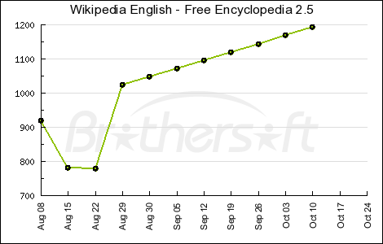
Wikipedia English – Free Encyclopedia 2.5

